Nixie tube Clock
Directions for use
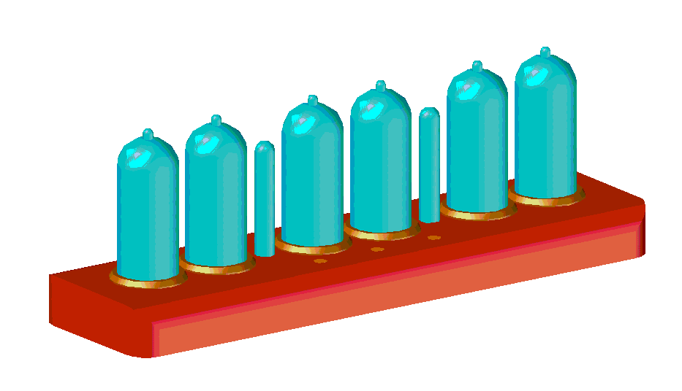 | 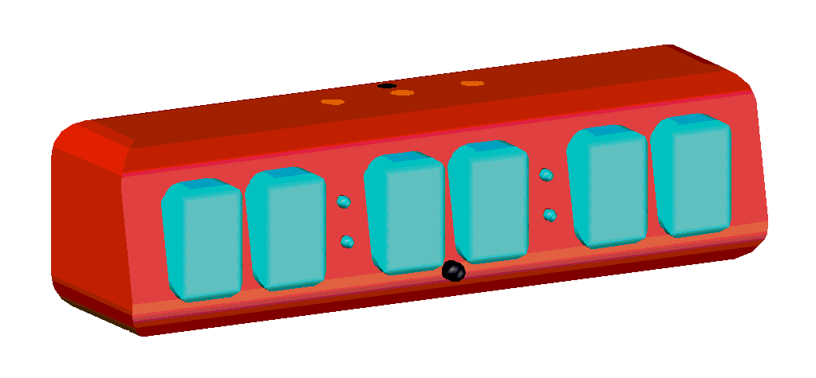

橡果工坊出品

Introduction of the clock
■ The clock parameters
voltage：DC5V
electricity：<800ma

■ The warranty treaty
# Clock non-manual damage is guaranteed for one year and the warranty is required to keep the internal label intact
# Wearing parts such as appearance and glass are not covered by warranty
# Each clock has its own sales card as proof of sale. Do not tear, alter or discard it
# If the warranty period is exceeded or man-made damage is caused, the shop will provide repair;Charge for materials and hours
# Because the damage is very serious, it cannot be repaired. Please negotiate for a new one
■ Important note
# Users are strictly forbidden to disassemble and repair, once disassembling or repairing, the shop will not after sale.
# Do not use in damp environment
# Children are not allowed to touch the clock.
# Power USB power interface is fragile, do not drag to avoid damage
# This clock is a DIY work, there are some flaws or imperfections, please include
# Please believe that we will try our best to make each work present its best condition
■ Contact information
QQ:4164420 WeChat：dls0709 E-Mail：dls20@qq.com

Please scan the qr code below and follow our WeChat public number to make it more convenient to contact us:

Our website：www.diym.vip

Clock APP/ small program acquisition and use
Applet of WeChat | Android APP download
WeChat scan the following two-dimensional code or search the small program "果然时钟" can be opened | The qr code below scan or enter the webpage to download the android APP installation package  ：http://www.diym.vip/guoran.apk
 | 

Open the software and look for the clock | Select the clock to connect to
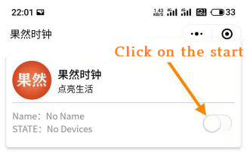 | 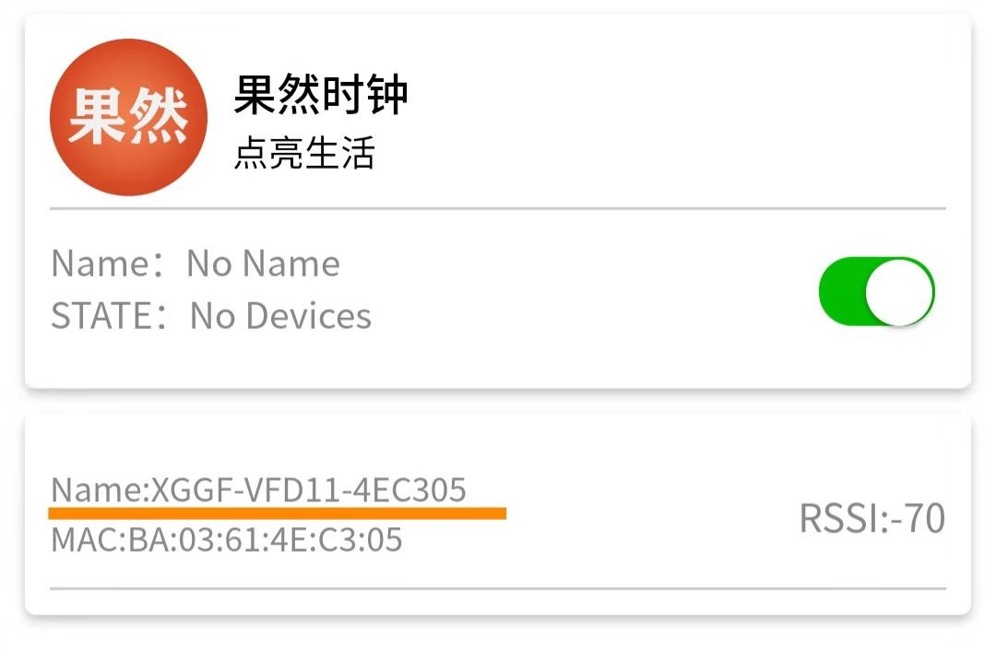
Open the interface of the software：
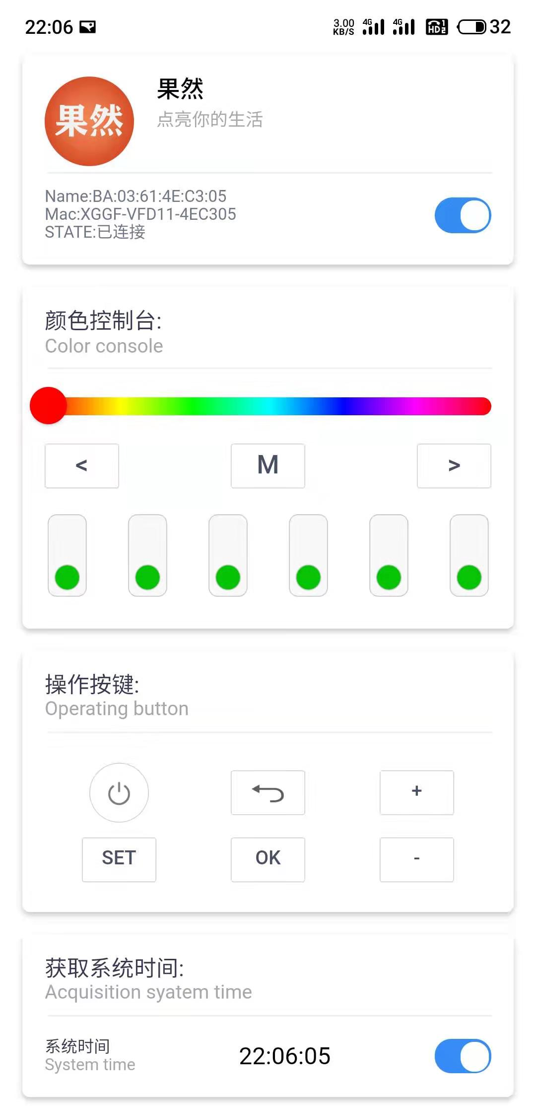 | 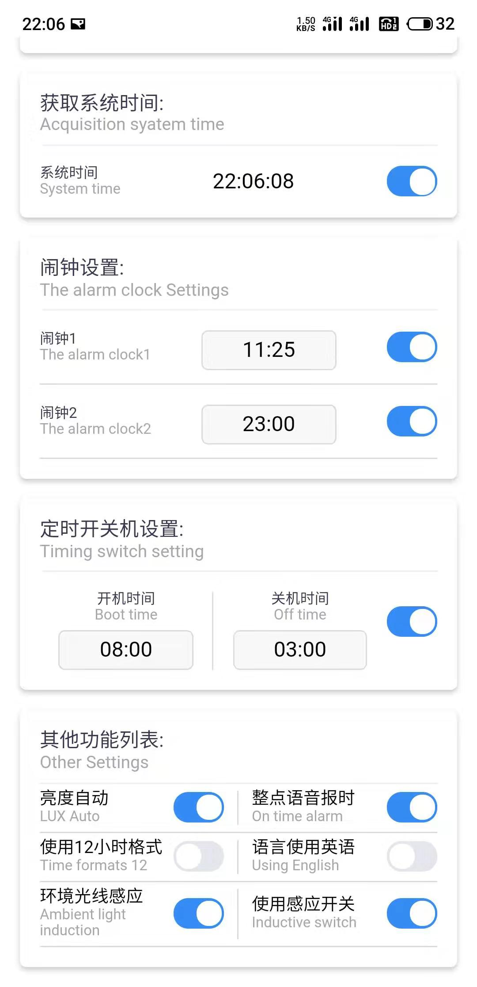
Notice: 1. If the software fails to load properly, please close the software and try again.
2. If the clock cannot be found, it may be the compatibility problem between mobile phone and software, please change the mobile phone for testing.
Clock key
- Clock touch buttons and functions
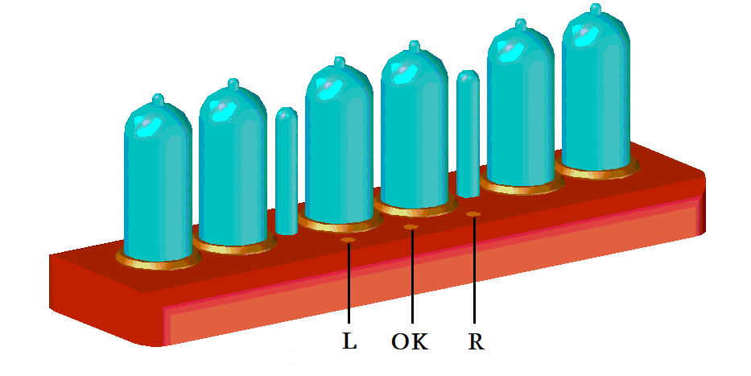 | 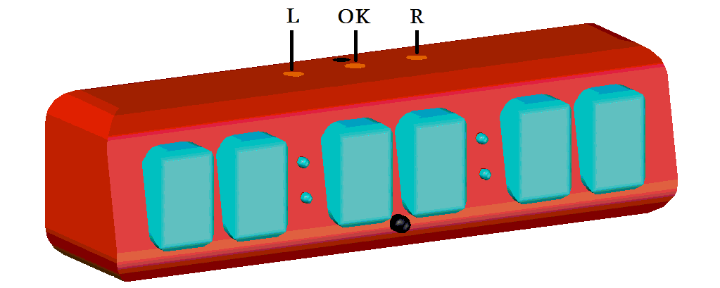
1 | 2

 | Ket | operation | function
1 | L | click | Turn backlight on and off; Parameter adjustment "+"
2 | OK | click | Turn on and off the clock; Parameter adjustment "OK"
3 | R | click | Display date; Parameter adjustment "-"
4 | L、R | At the same time press | Enter and exit clock Settings
5 | OK、R | At the same time press | Turn on the timer

IR remote control | Remote control button function
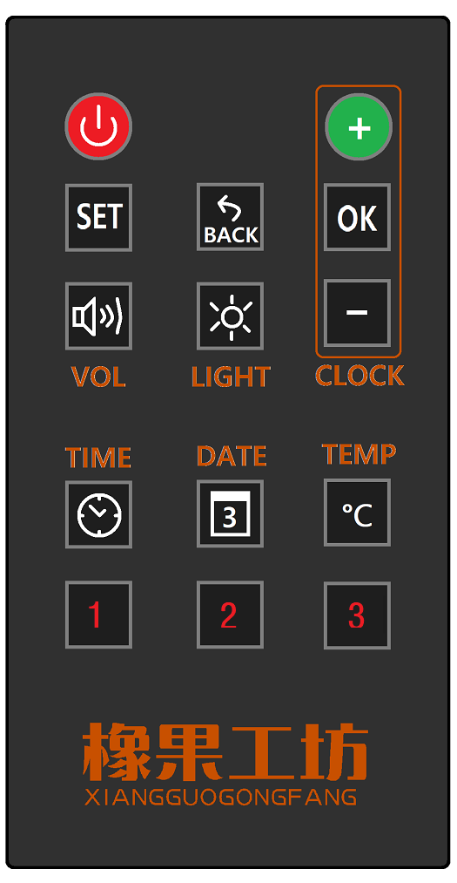 |  | + |  | Back
 |  | OK |  | Volume set
 |  | - |  | Luminance
 |  | ON-OFF |  | Time
 |  | SET |  | Date
 |  | brightness adaptation |  | Change color
 |  | Fixed color |  | Color change mode
Notice: Button for backlight control

Enter the set action
- There are two ways to access the Settings function
1： Simultaneously press the clock to touch the button "L, R"
2：Press the APP/ remote control button“ ”
Display ▶ | 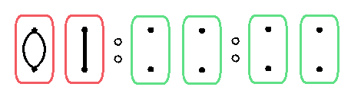

2、There are two ways to exit the Settings function（Note: do the following under the main menu shown above)
1：Simultaneously press the clock to touch the button “L、R” | 2：Press the APP/ remote control button“”

3、Set display content
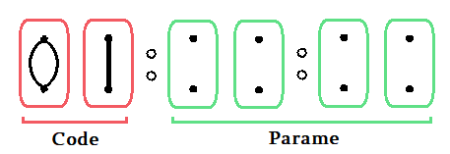
Note: LED backlight indicates setting items and status

4、Key function when setting
▼Infrared remote control |  |  | ▼The clock button
 | add“+” |  | L | add“+”
 | OK |  | OK | OK
 | Exit/return |  | R | subtract“-”
 | subtract“-”

Note: in the setting interface, the clock has voice prompts for each function. Please operate with voice prompts.LED backlight changes with Settings in real time, and red LED light indicator sets function code;The green LED indicates the parameters being changed.
Set the project function reference table
Code | Project | Parameter | Corresponding function
01 | Time set | 1 | Connect to the phone bluetooth and set the time automatically
01 | Time set | 0 | Manually set the year, month, day, week, and second in turn
02 | Alarm 1 | 1 | open | Turn on and adjust the alarm time
02 | Alarm 1 | 0 | close | Shut the alarm clock 1
03 | Alarm 2 | 1 | open | Turn on and adjust the alarm time
03 | Alarm 2 | 0 | close | Shut the alarm clock 2
04 | Digital variation pattern | 0 | Normal change
04 | Digital variation pattern | 1 | Cross the gradient
04 | Digital variation pattern | 2 | Crossbar transition
04 | Digital variation pattern | 3 | else
05 | Colons of display | 0 | close
05 | Colons of display | 1 | open
06 | The brightness Set | 0 | automatic adjustment
06 | The brightness Set | 1 | Level 10 manual adjustment
07 | Volume set | 0~7 | Prompt sound volume setting,"0" silently
08 | Display mode | 1 | Display: hours, minutes, seconds
08 | Display mode | 2 | Display: hour, minute, week
08 | Display mode | 3 | Display: Month, day, week
08 | Display mode | 4 | Custom display
09 | Hour format | 12 | 12-Hour format
09 | Hour format | 24 | 24-Hour format
10 | Timing switch | 1 | Starting up Time,The time when the clock is automatically turned on
10 | Timing switch | 2 | Shutdown Time,The time when The clock shuts down automatically
11 | Hourly prompt | 0 | close
11 | Hourly prompt | 1 | open
12 | Night mode | 0 | close | Function: When the brightness level is less than 2, do not broadcast time
12 | Night mode | 1 | open
13 | Alarm bells music | 1~6 | 6 alarm clock music
14 | LED weekly mode | 0 | close | Note: The backlight represents the week with red, orange, yellow, green, cyan, blue and purple. The LED color cannot be changed manually after being turned on
14 | LED weekly mode | 1 | open
15 | External switch | 0 | close | Reserve the on and off interfaces for peripherals or DIY developers
15 | External switch | 1 | open
16 | Nixie tubes protection | 0 | Closed, not recommended
16 | Nixie tubes protection | 5~15 | Recommended 5 minutes
17 | Language | 0 | Voice broadcast in Chinese
17 | Language | 1 | Voice broadcast in English
18 | Reset the clock | 00 | Do not revert to the default state
18 | Reset the clock | 11 | Restore the clock to its default settin

Timer function (supplement)

1、Two ways to access the timer function
1： Simultaneously press the clock to touch the button "OK, R"
2：Press the APP/ remote control button“ ”
Display ▶ | 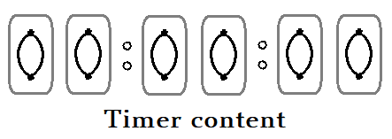

▼Infrared remote control
 | Reset timer and pause the timer
 | Timer starts/stops working |  | Exit timer

The clock button
Key | operation | function
L | click | Reset timer and pause the timer
OK | click | Timer starts/stops working
R | click | Exit timer

Note: Avoid misoperation, unable to shut down under the state of timer;In the timer function No timing action is performed while entering other functions.

